JEREMIAH NYAGAH NATIONAL POLYTECHNIC
ELECTRICAL AND ELECTRONIC DEPARTMENT
AUTOMATE AN ELECTRICAL MACHINE
ASSESSMENT I

Qualification Code: 071306T4EEN
Qualification: Electrical Engineering Level 6
Unit Code: ENG/OS/PO/CR/05/6
Unit of Competency: Automate an electrical machine

INSTRUCTIONS
- Attempt ALL questions in Section A and TWO questions in section B
- Marks for each question are indicated.

SECTION A (40 MARKS)
Answer ALL questions in this section.
- State FOUR factors that must be taken into consideration when designing an automation system for electrical machines. [4 marks]
- Name THREE common components used in automation systems for electrical machines.
[3 marks]
- Explain FOUR reasons for carrying out a simulation before implementing an automation system. [4 marks]
- List TWOdocuments typically kept by an automation system engineer. [2 marks]
- Distinguish between open-loop and closed-loop control systems, [4 marks]
- List THREE tools used during the installation of automation components. [3 marks]
- Using a labeled diagram, differentiate between ladder logic and function block diagram programming languages used in PLCs. [4 marks]
- Define the following terms as used in automation: [3 mark ]
- Timer
- Counter
- Scan time
- Compare wired and wireless communication in automation systems, giving one application example for each. [4 marks]
- Draw the Logo 8 Siemens PLC connection/wiring diagram of a DOL motor starter controlcircuit in figure 1. [4 Marks]
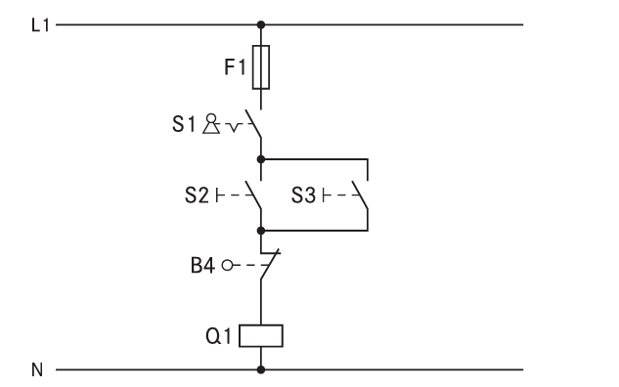
Figure 1
- Figure 2 shows a PLC module. Name the parts labeled A, B , C D and E [5 marks]

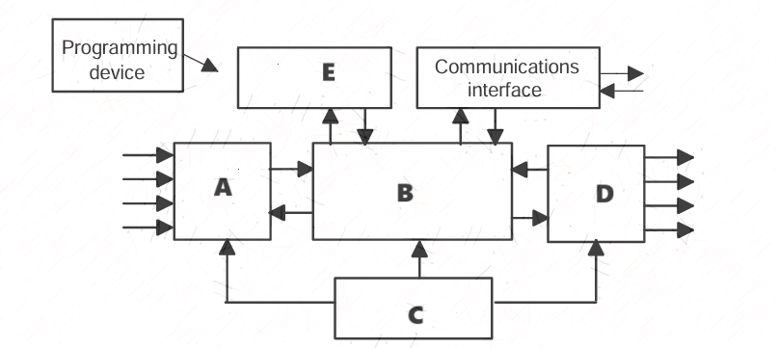
Figure 2

SECTION B (40 MARKS)
Answer TWO questions from this section.
- a) Explain the procedure for programming a PLC to automate an electrical machine, including steps like logic design, coding, and simulation. [8 Marks]
b) Parts are moving on the conveyor from one process line to other with a constant speed. Out of 1000 part, one part is taken out for quality check. Implement automation of this process in PLC using any programming language.
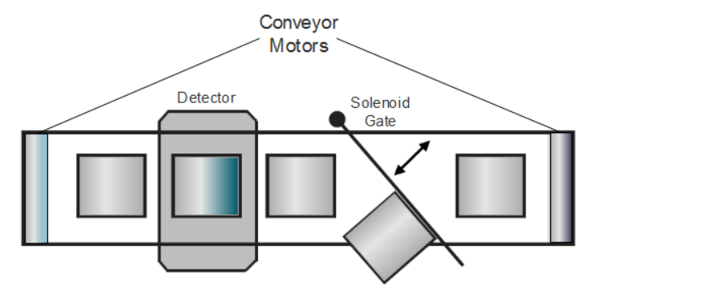
Figure 3
- a) With aid of diagram describe FOUR sensors used in automation with diagrams.
b) Tower lamps control system works as follows;
- When switch 1 is pressed, lamps 1,2, and 3 get on,
- When switch 2 is pressed, lamps 4 and 5 get on,
- When switch 3 is pressed, lamps 1, and 5 will get off.
Develop a PLC program to control this operation [12 Marks]
- a) Discuss FOUR advantages of using PLCs over traditional relay-based control systems.
[8 Marks]
b) A traffic light has red, amber, and green lamps. A red lamp gets on for 30 sec, then an amber lamp gets on for 10 sec and finally, the green lamp will get on for 20 sec. This cycle will continue for 1 minute. Develop a PLC program to perform the operation.
[12 Marks]

GOOD LUCK

